**Capstone Project – Superstore Sales Performance**

**View 1 – Total Sales**  
Connected the data set to the tableu

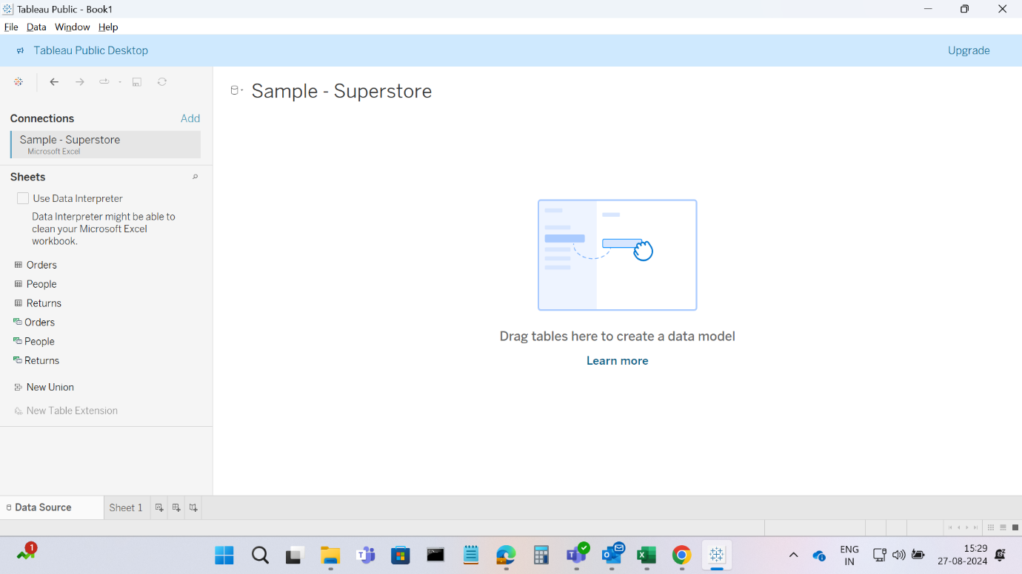

Created a new worksheet, Displayed the Total sales By dragging the ‘sales’ field to the text under marks card showing total sum of sales and formatted the Sales as Thousand (K)

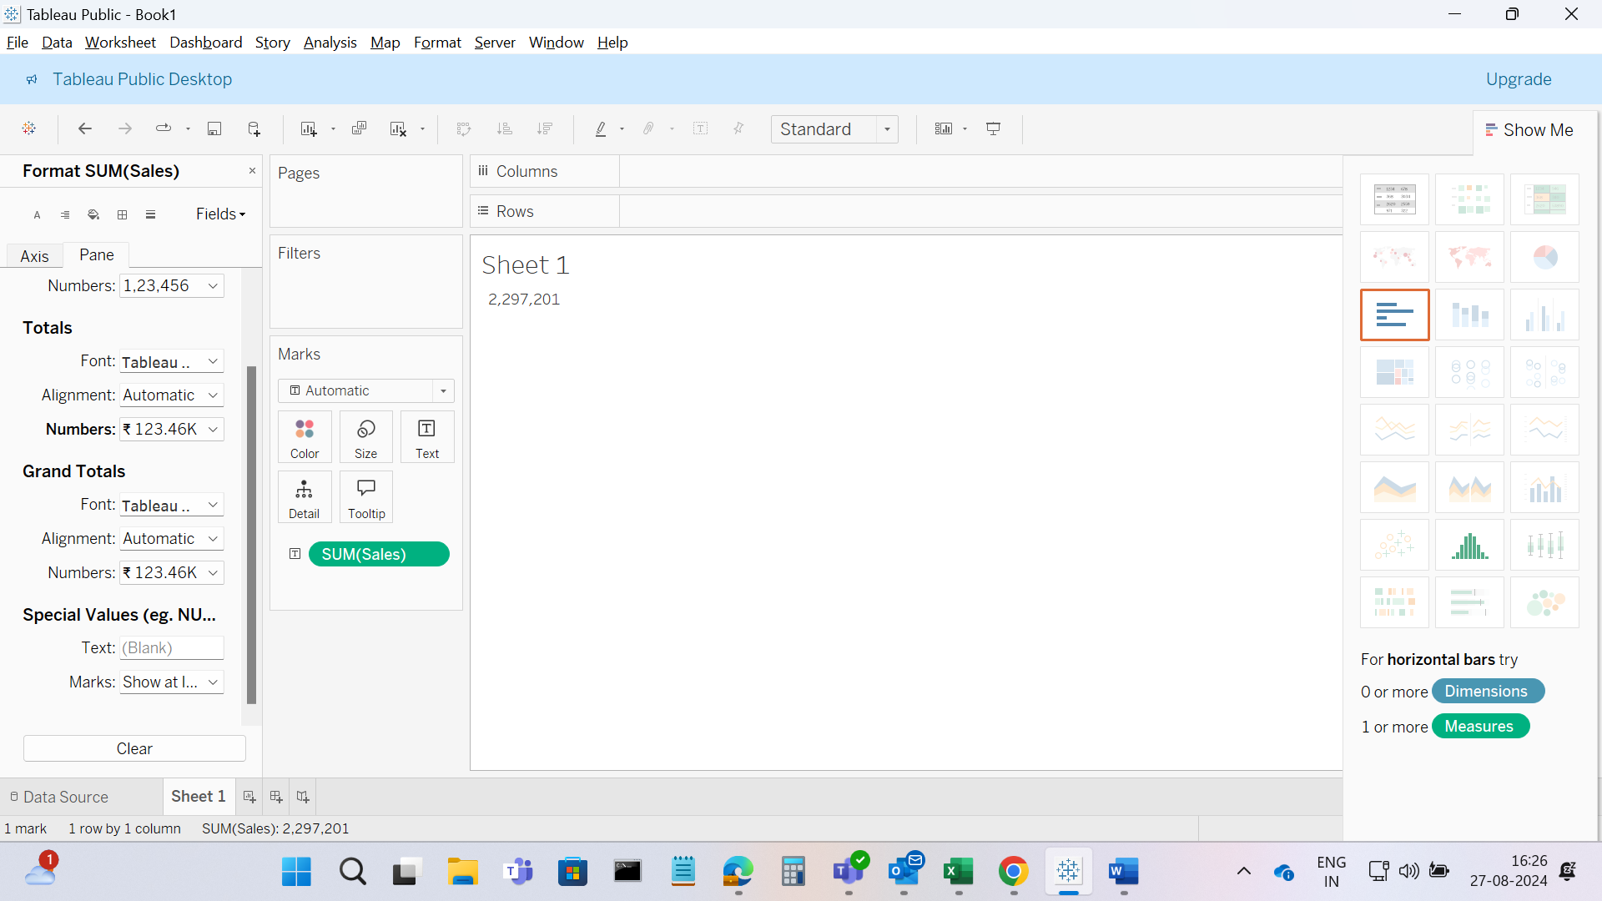

Changed the text color to #76b7b2 and disabled the tooltip also renamed the sheet as Total Sales and can be viewed in Tableau public

**View 2 – Total Profit**

Created a new worksheet, displayed the Total profit by dragging the profit field to the text box under Marks card, formatted the profit at Thousands (K), changed the text color to #76b7b2 and tooltip is disabled

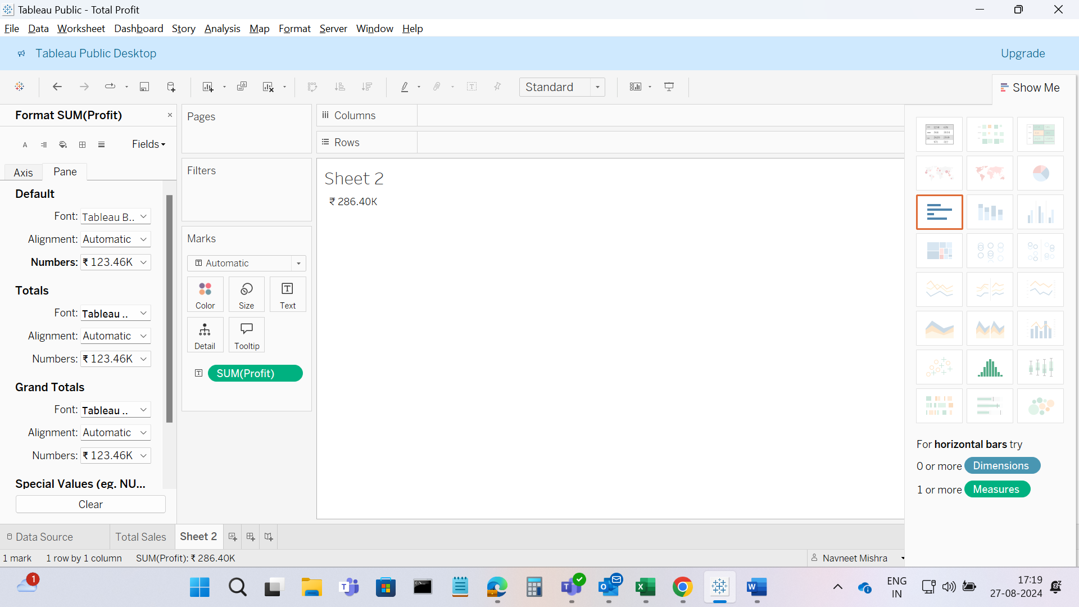

Set the Background color and saved the worksheet as Total Profit can be viewed in Tableau public.

**View 3 – Total Volume**

Worksheet created for Total Volume

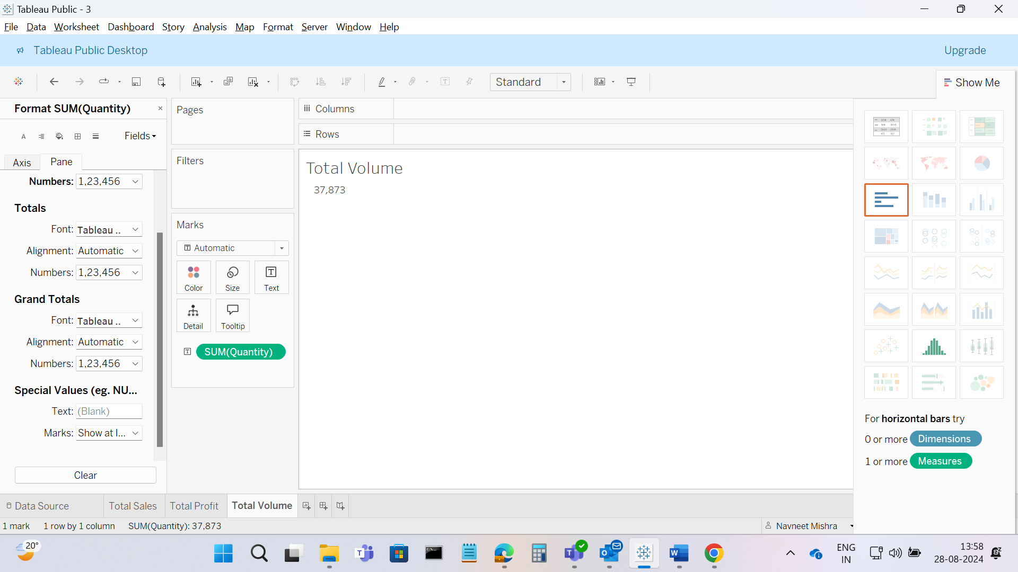

**View 4 – Calculate Sales Per Customer**

From the analysis menu created the calculated field and named Sales Per Customer and entered the formula - SUM([Sales]) / COUNTD([Customer ID])

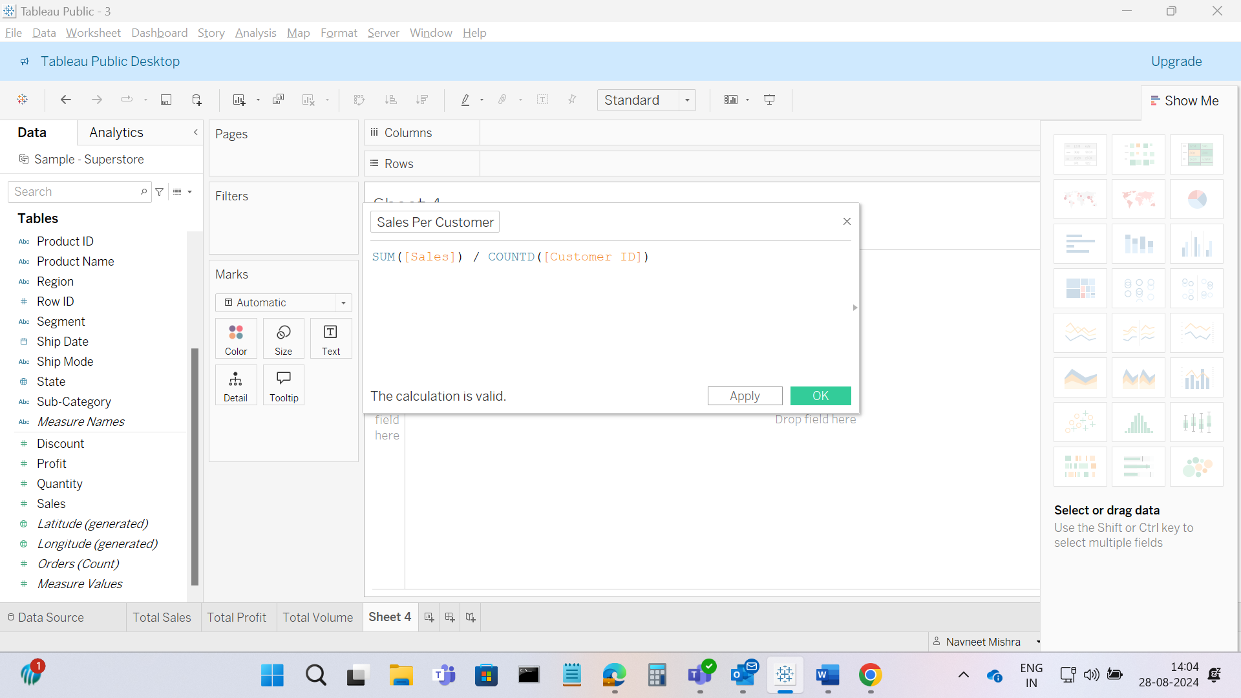

Now Dragged the Sales Per Customer field from Data pane to the Text shelf under Marks Card

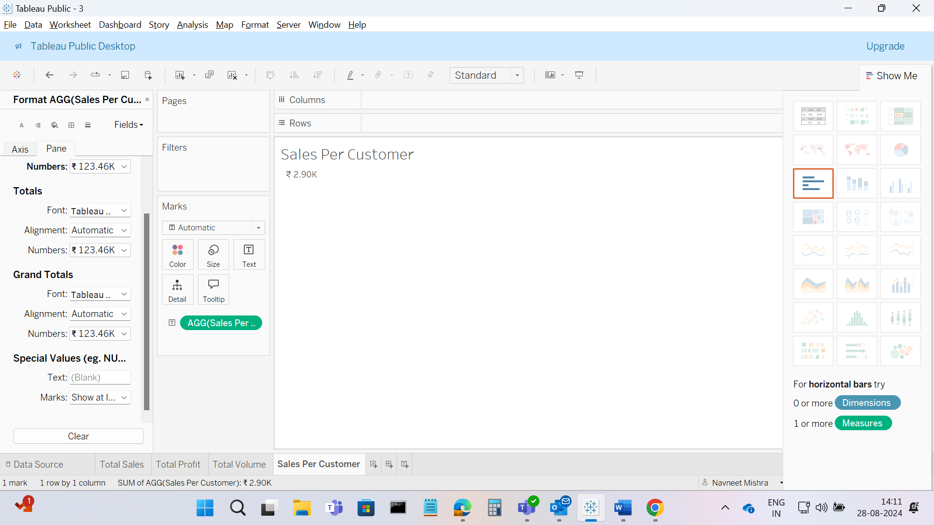

**View 5 – Pie Chart**

Created new work sheet, Dragged region to the columns shelf and sales to the Rows shelf

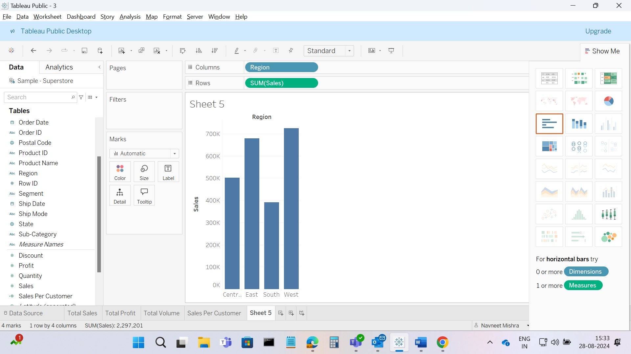

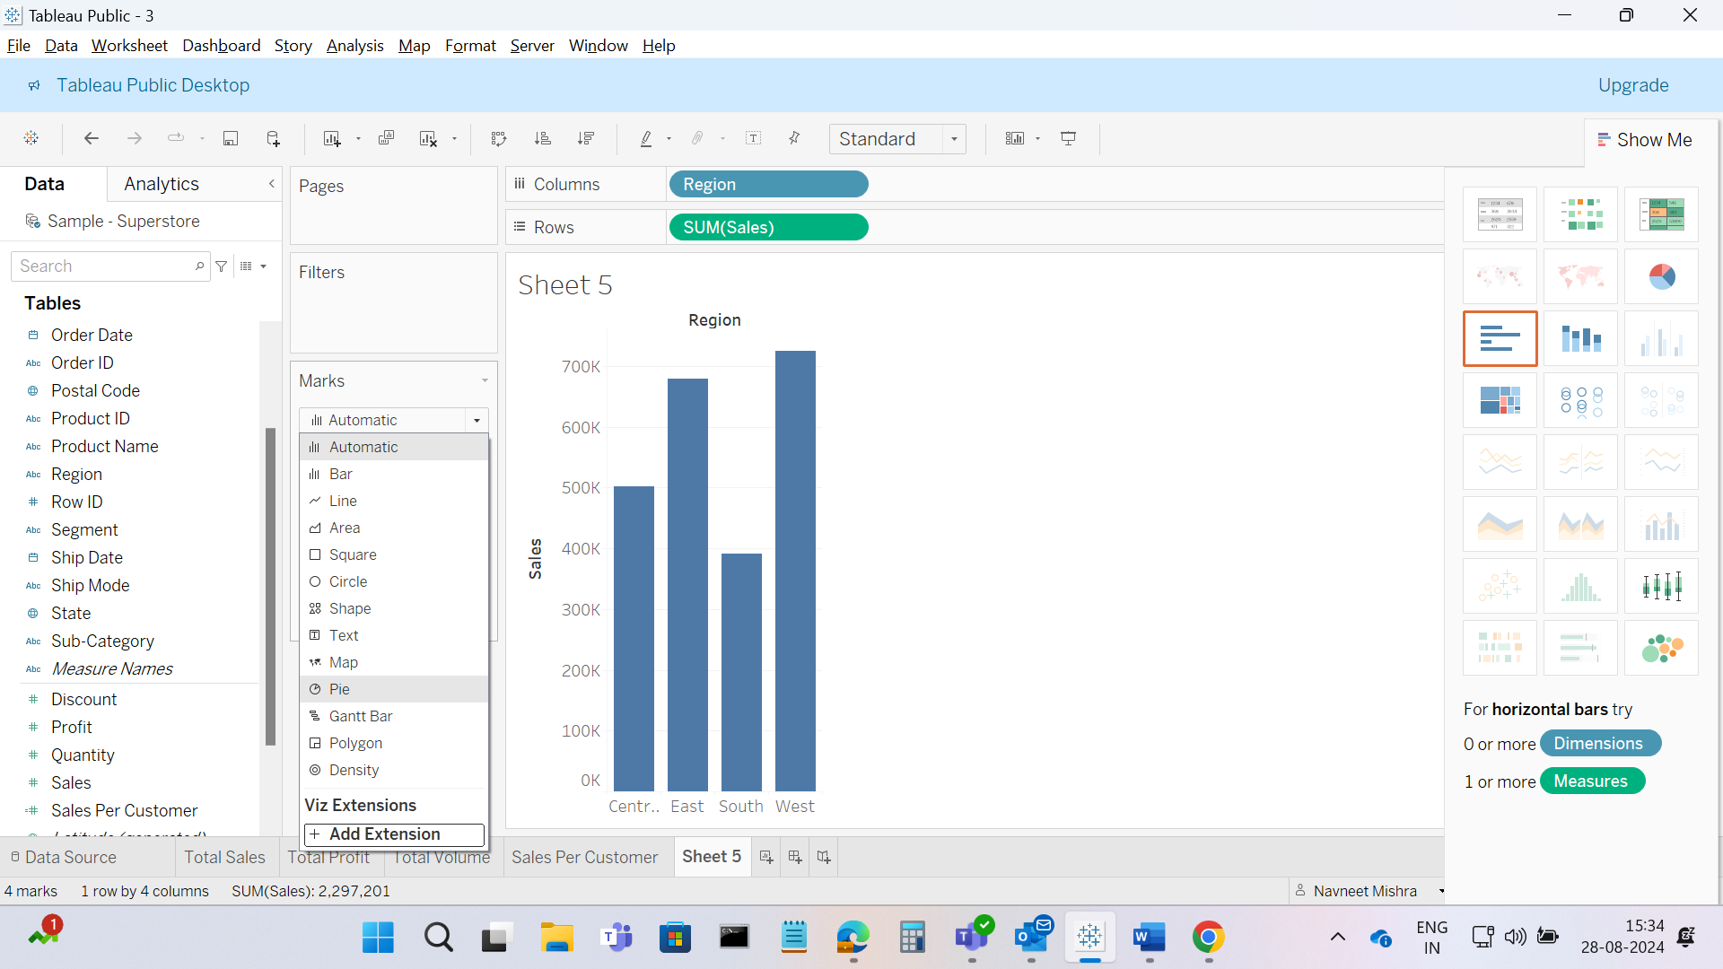

Now converted the Mark type from automatic to Pie, moved sales from rows to angle, moved region from columns to color and also drag sales from data pane to the Label in the Mark

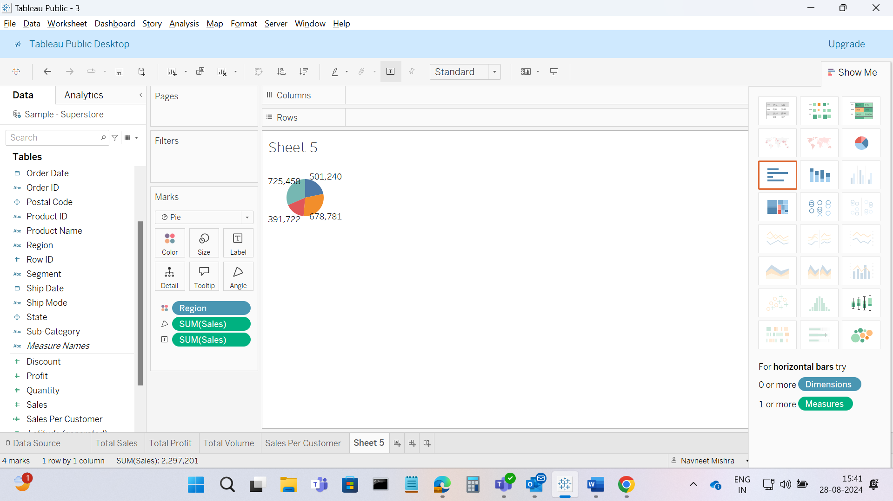

Now Summer color is selected and added black color to the border

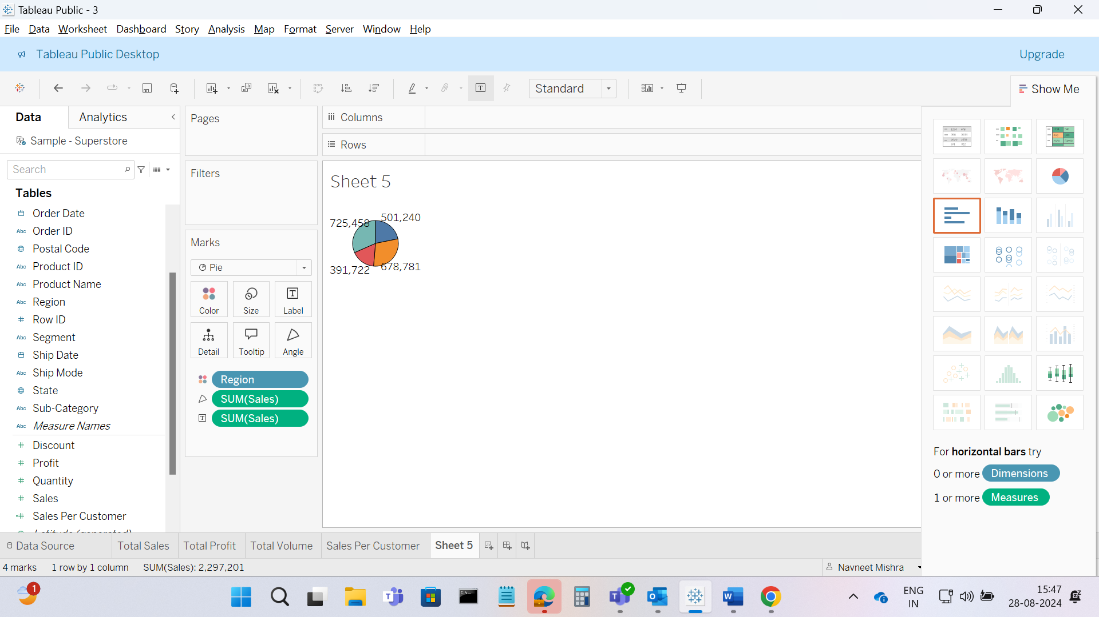

Tooltip is applied with the code - <b><font size="10">Region: </font></b><font size="10"> <b><Region></b></font><br/>

<b><font size="10">Percent of Total Sales: </font></b><font size="10"> <b><SUM(Sales) Percent of Total></b>%</font><br/>

<b><font size="10">Sales: </font></b><font size="10"> <b>$<SUM(Sales) K></b></font>

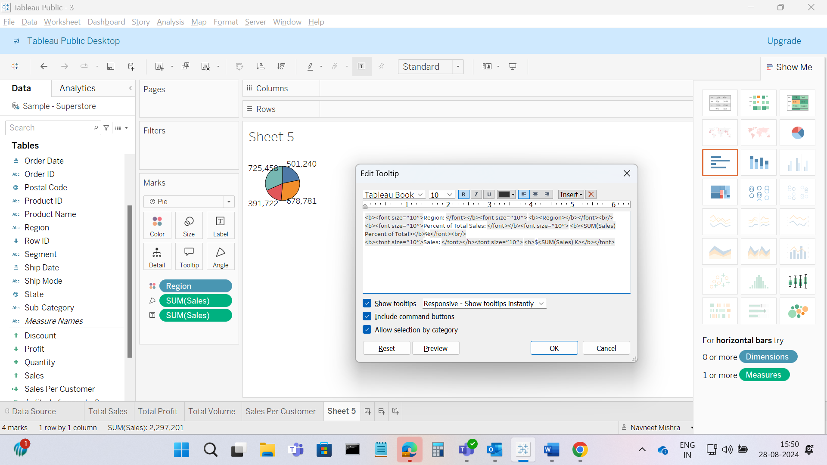

Further dragged Order date, segment, ship mode and state from data pane to filter shelf

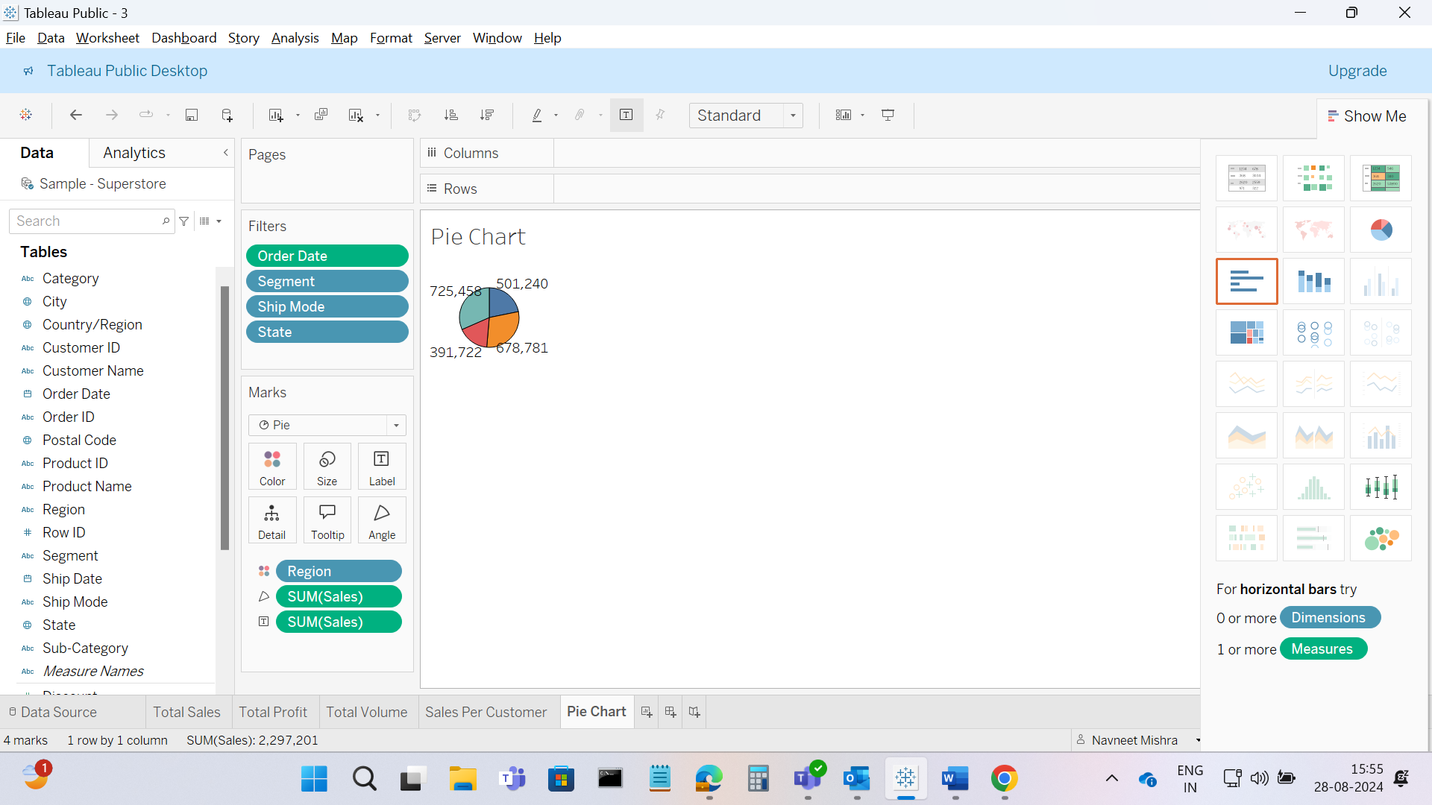

**View 6 – Bar Chart**

Created new parameter in the data pane named Top N States, selected data type as integer and selected range from 1 to 100.

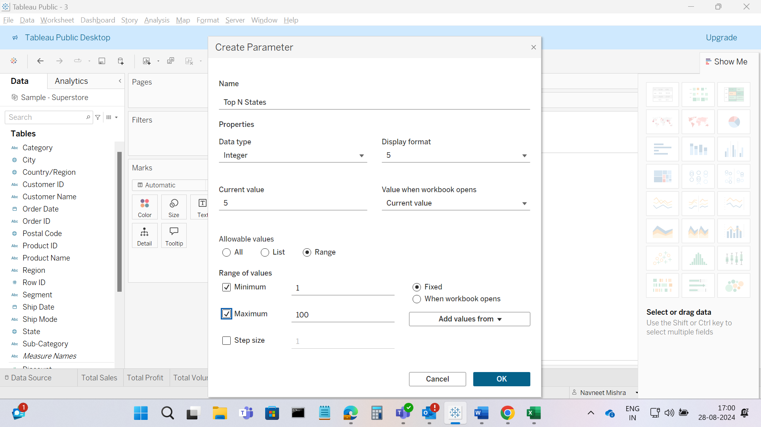

Also created a calculated field named Top N States by Sales and add the formula - RANK(SUM([Sales])) <= [Top N States]

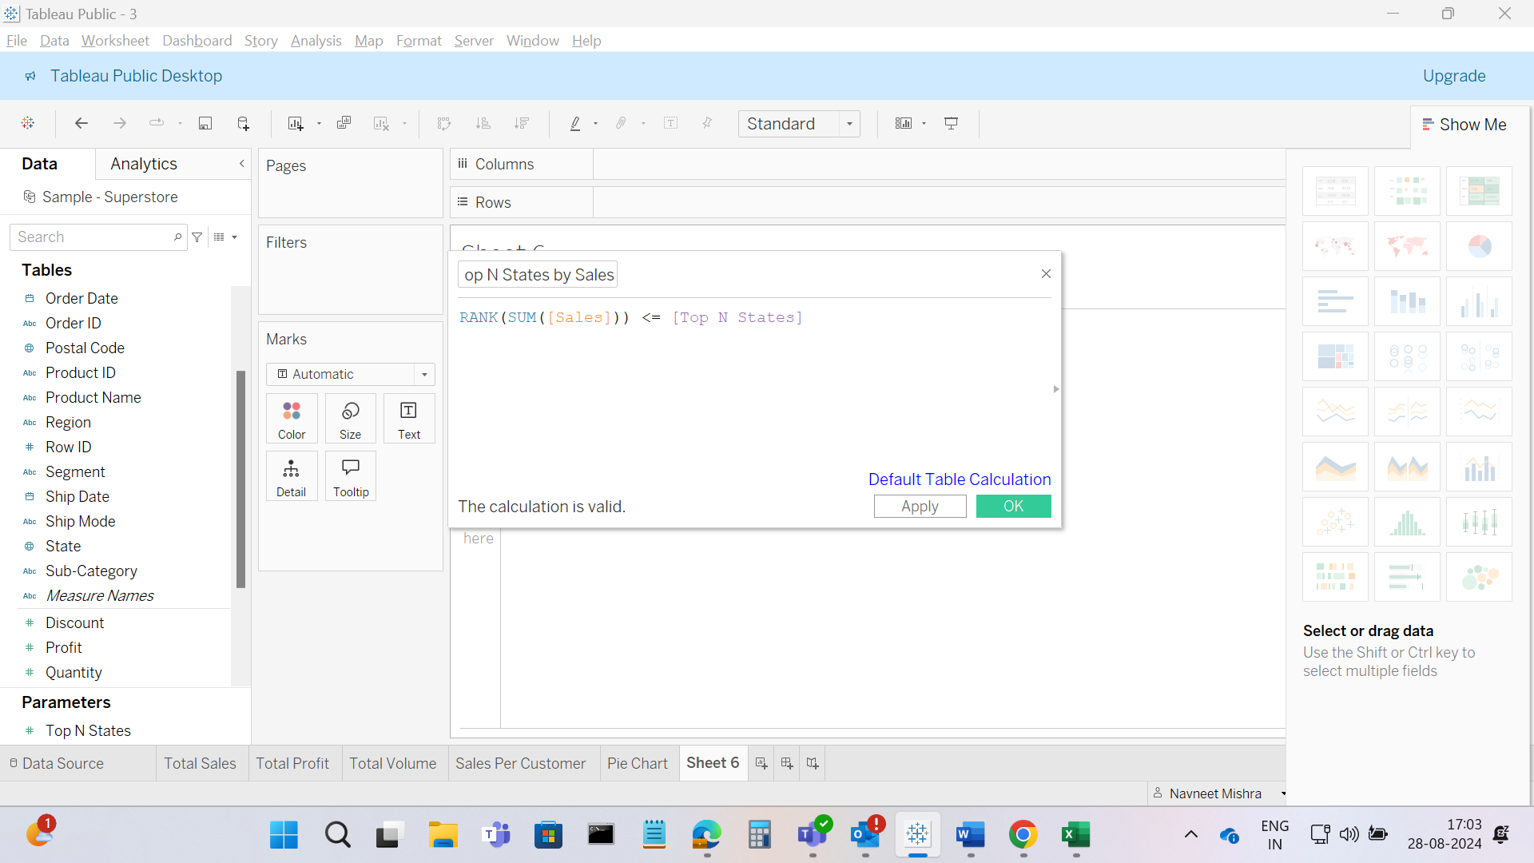

Then, Build the Bar chart by dragging states to rows and sales to the columns from the data pane

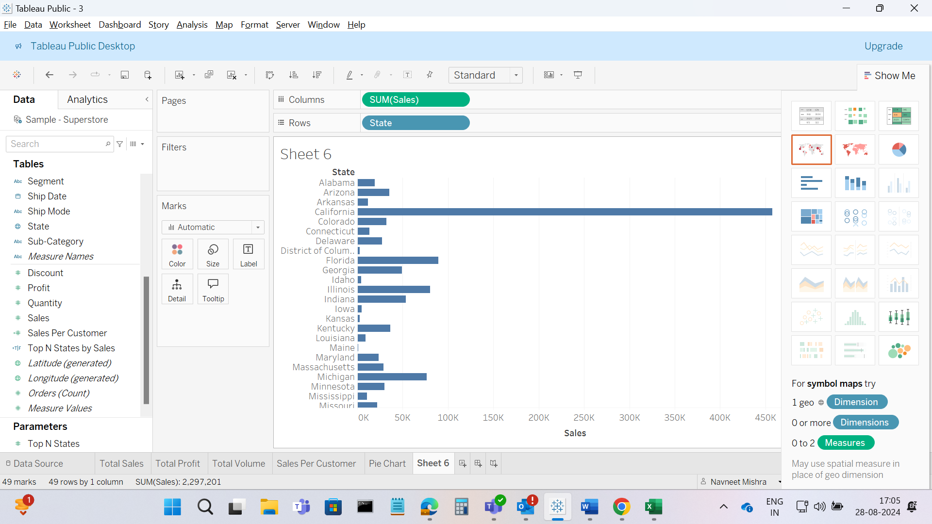

Then dragged the Calculated Top N states to the filter shelfs and select True from the dialog box so that it displays the Top N states by sales.

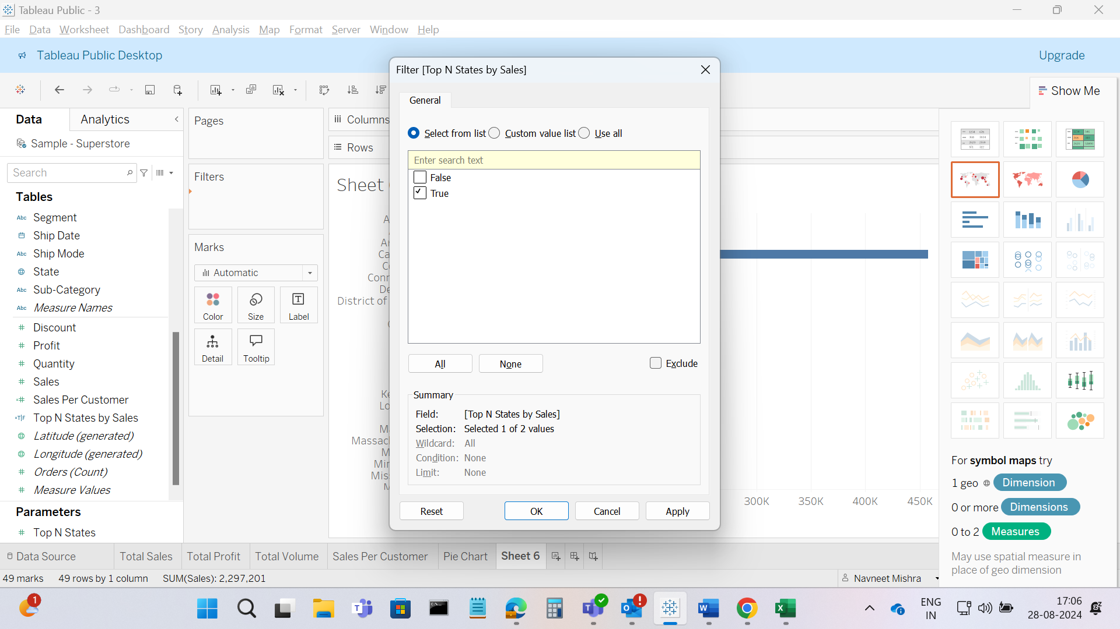

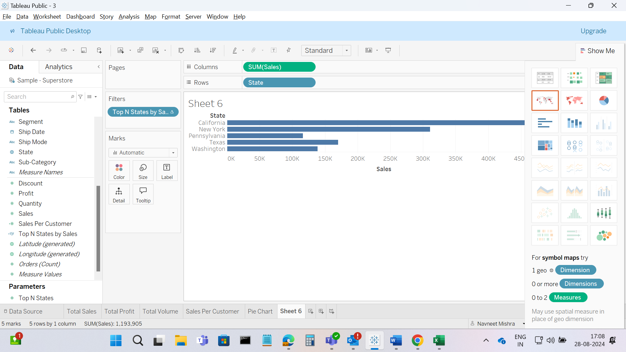

Then select the States in the rows shelf and select the descending order.

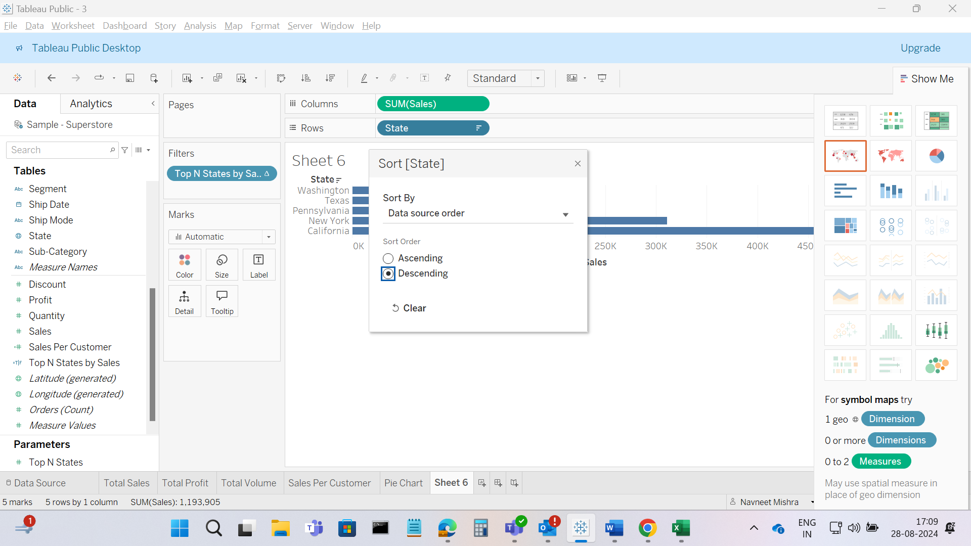

Bar Chart created

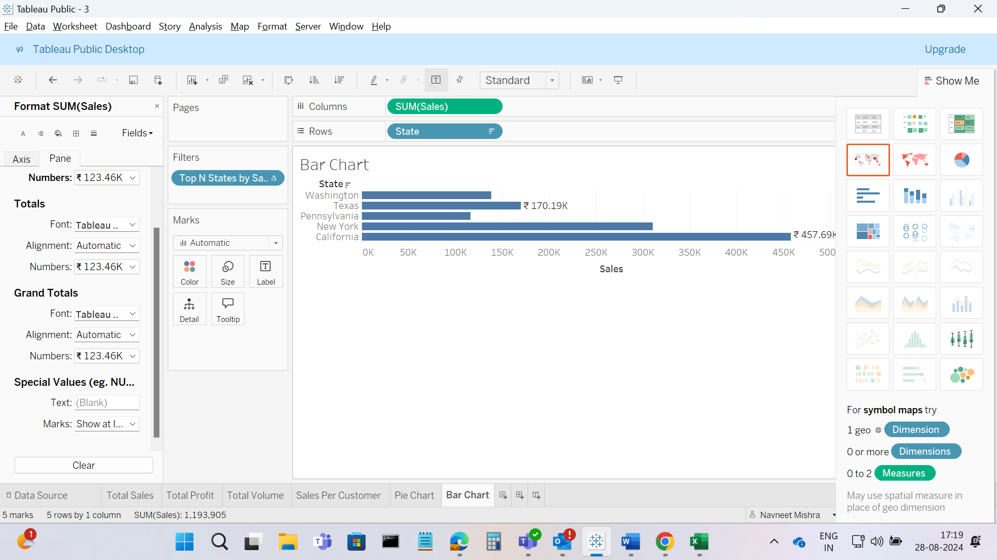

**View 7 – Bubble Chart**

Dragged Sub category to rows and sales to the colomns shelf from the data pane and then changed Mark type from Automatic to circle.  
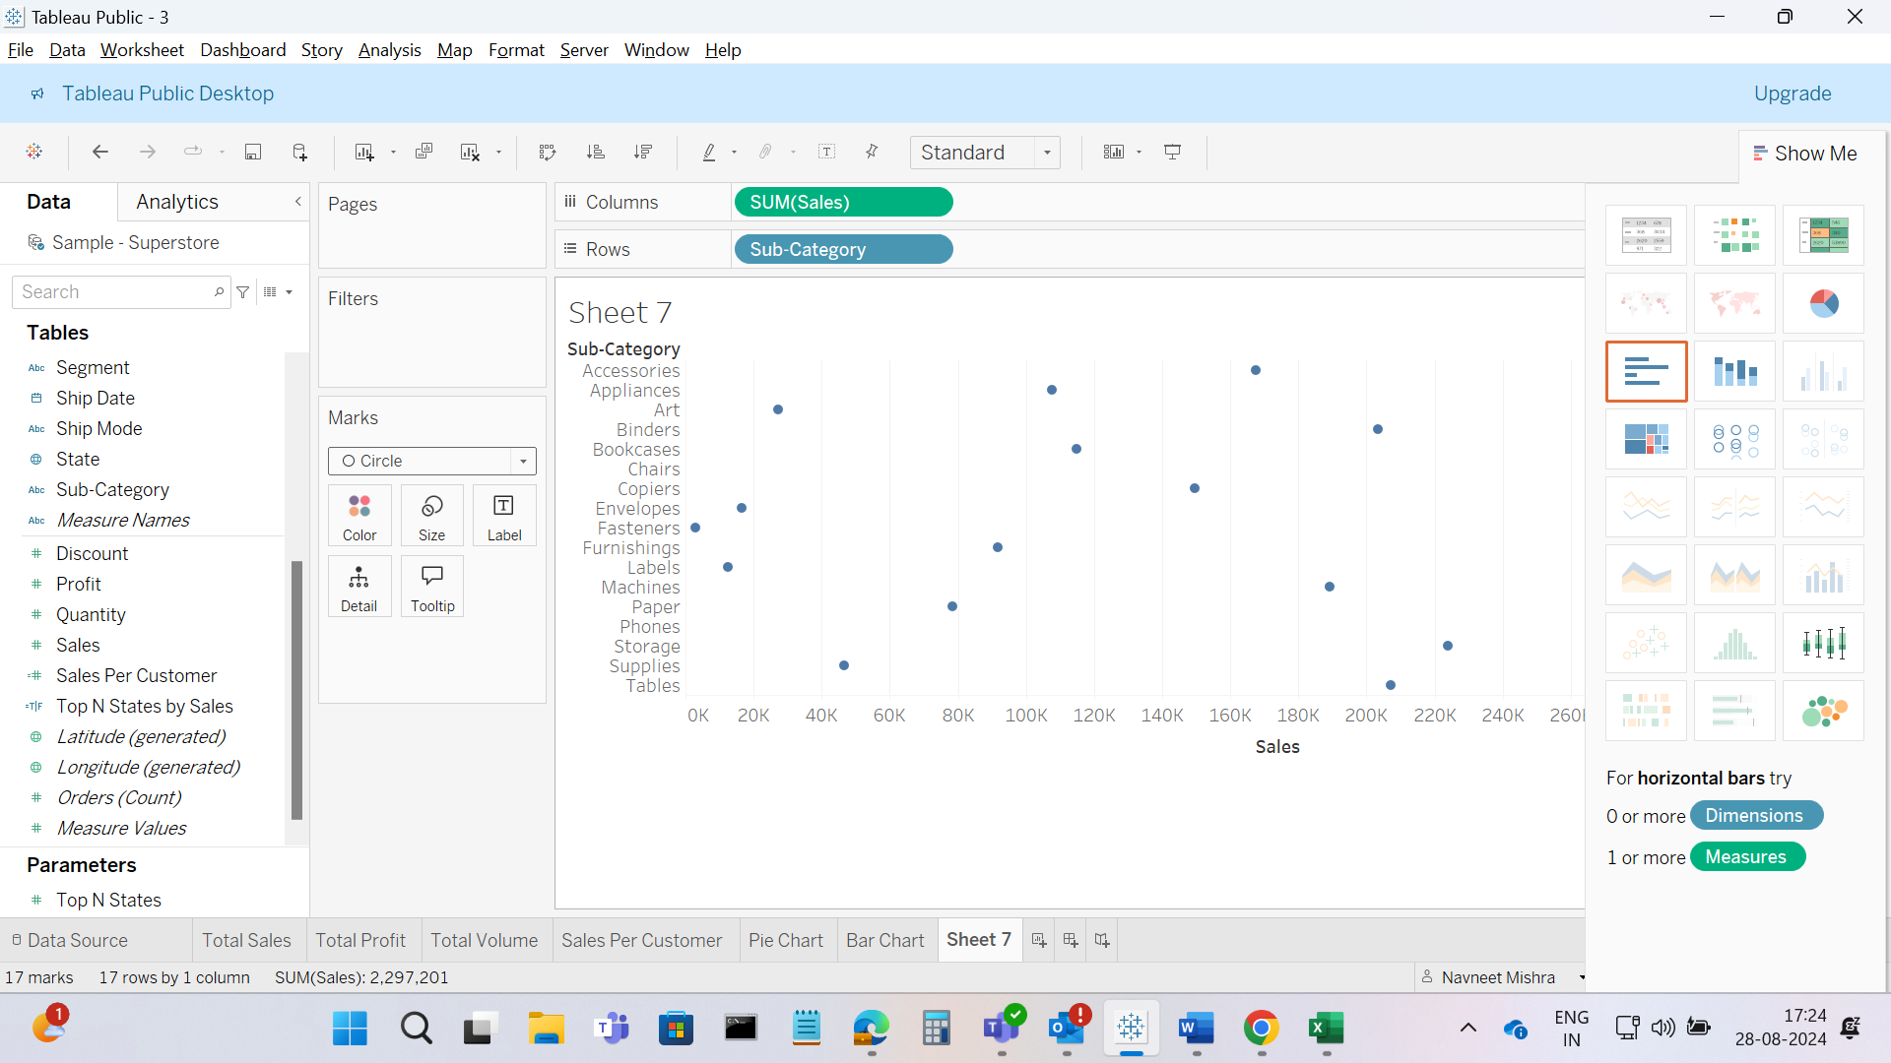

Then Dragged Sales from Columns to Size box in the Mark and Category from Data Pane to color box.

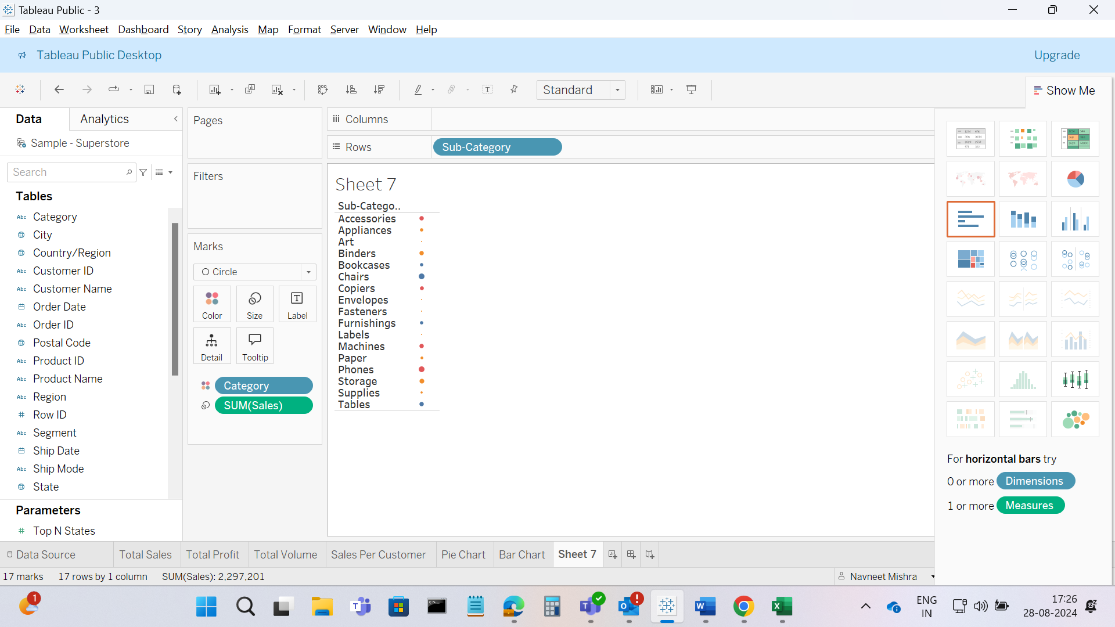

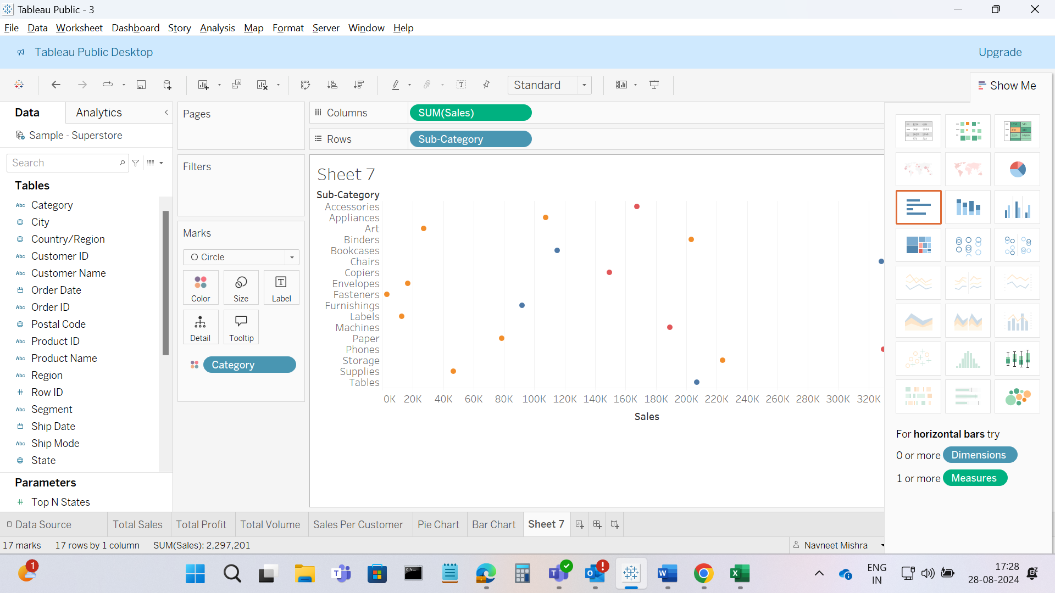

**View 8 – Line Chart**

Dragged Order date to the Columns from data pane and customize to the month/year format, dragged Sales to the rows

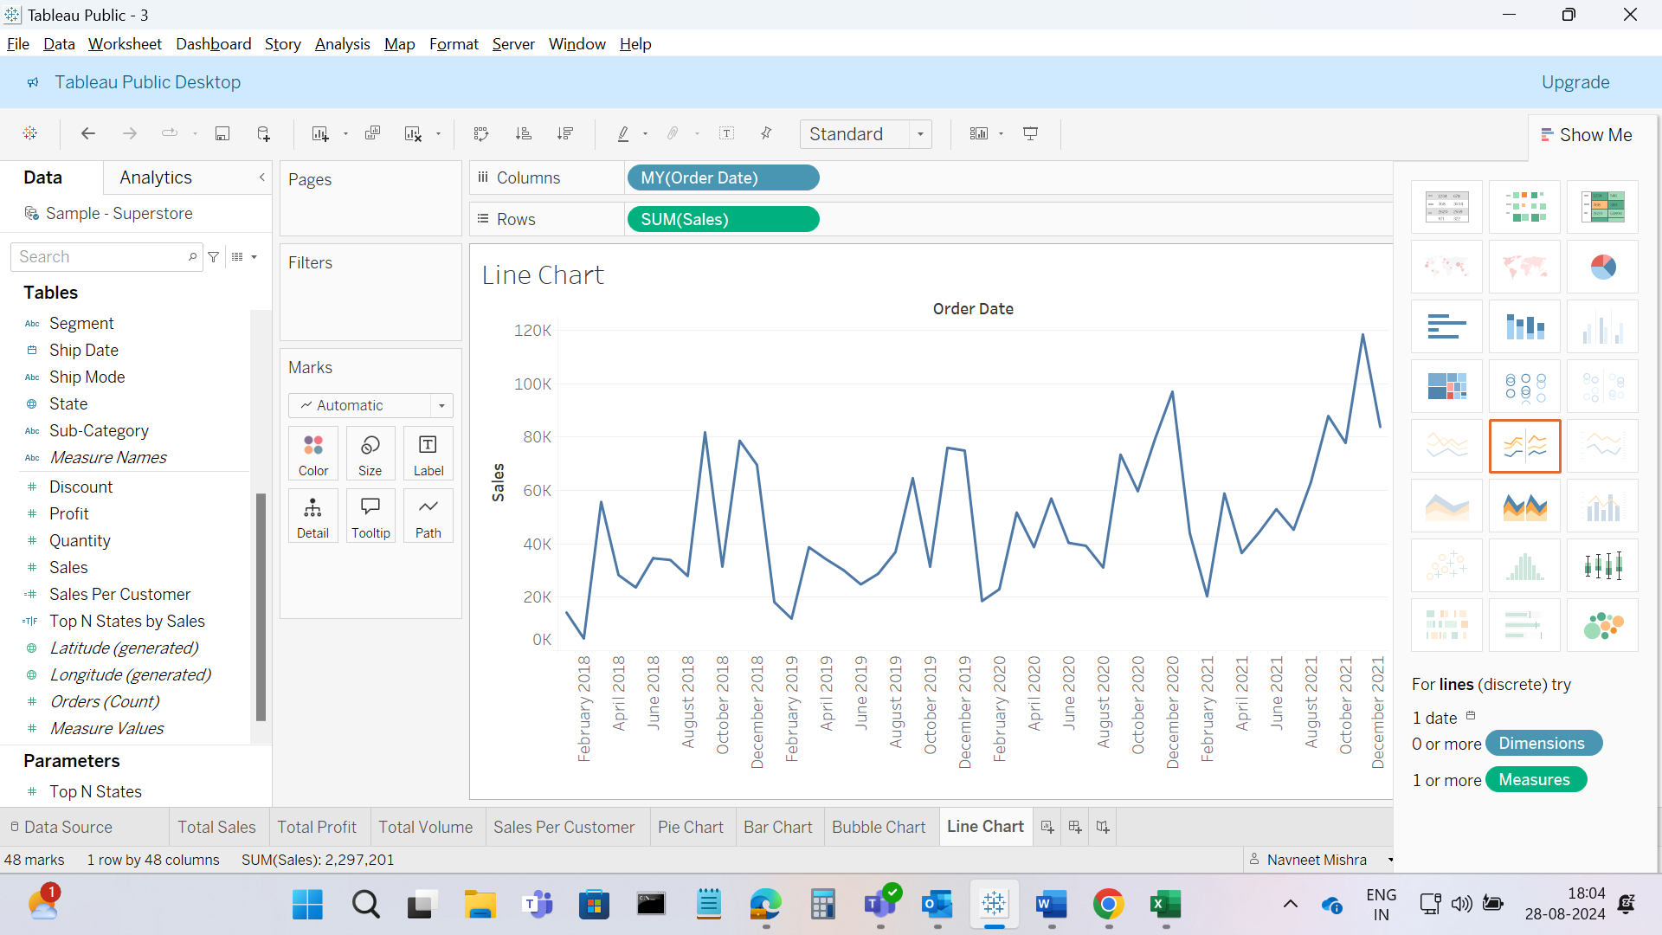

Then customize the Tootip with the code - <b><font size="10">Date: </font></b><font size="10"><b><MONTH(Order Date)></b> <b><YEAR(Order Date)></b></font><br/>

<b><font size="10">Sales: </font></b><font size="10"><b>$<SUM(Sales) K></b></font>  
  
and Hides the Title Axis

Also Dragged the Orderdate to the filter shelf and selected the Date of range.  
Also Colored the Tab  
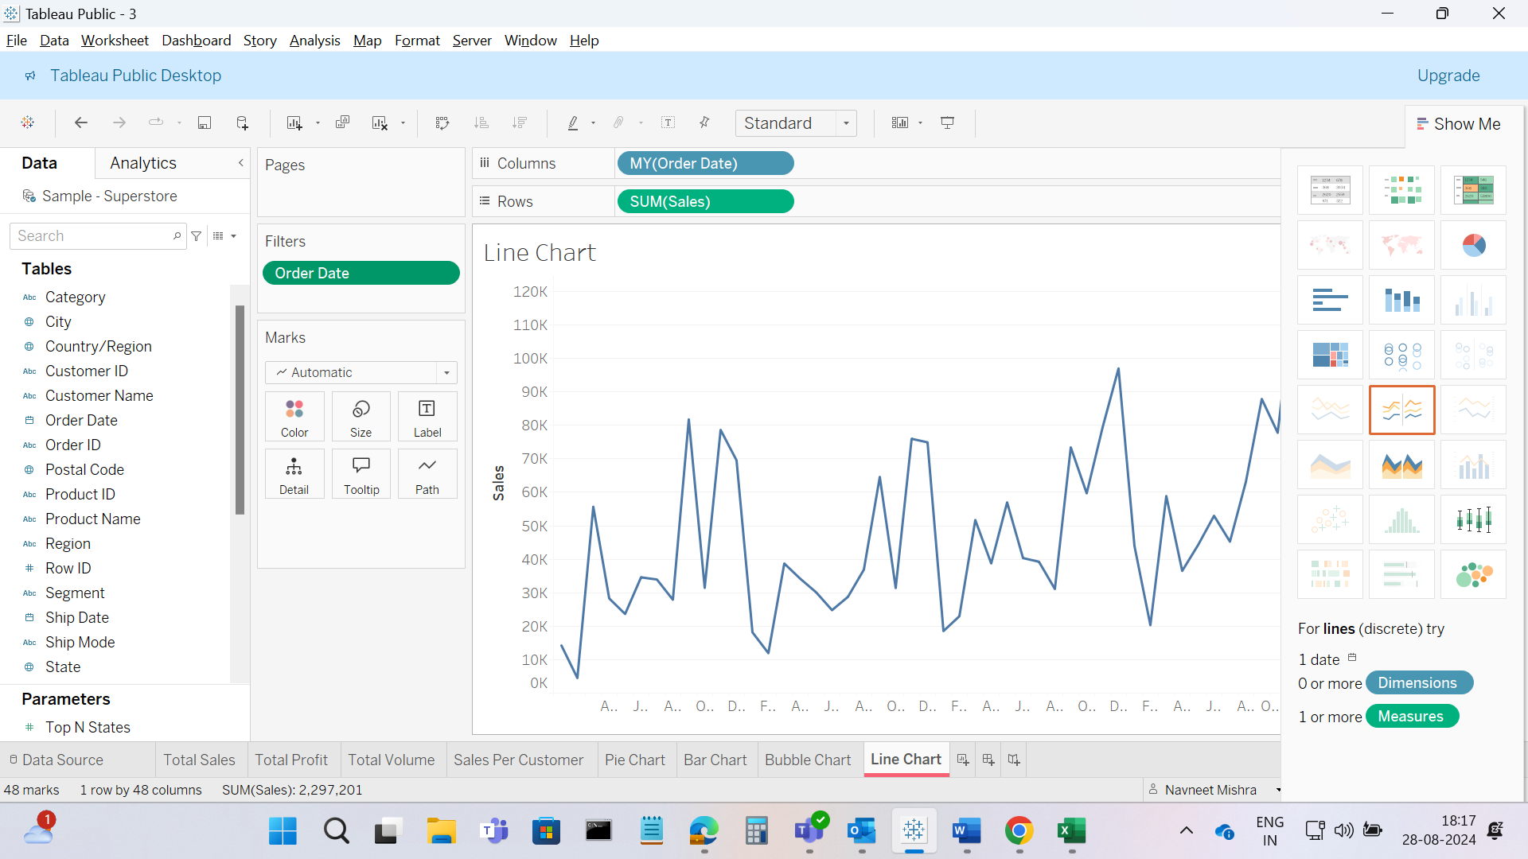

**Dash Board – Sales Dashboard**

Created a New Dashboard named Sales Dash board, make the size width 1055 px and Height 850 px.

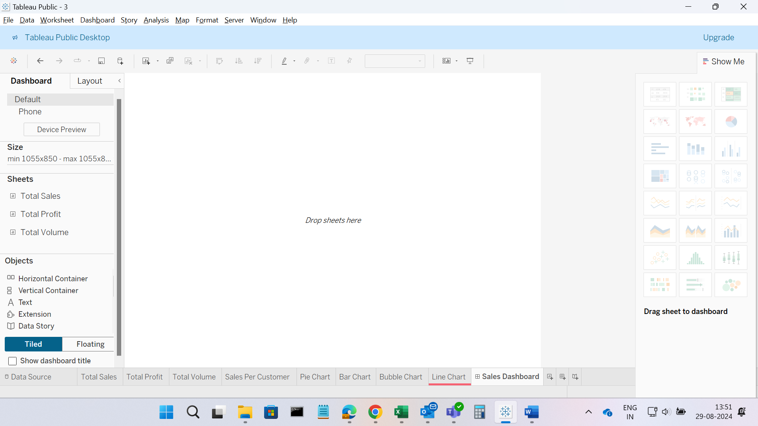

Then, Add text Object named Superstore Sales Performance to the top of the Dashboard and add text object named Sales Overview of the Superstore data below the Superstore Sales Performance.

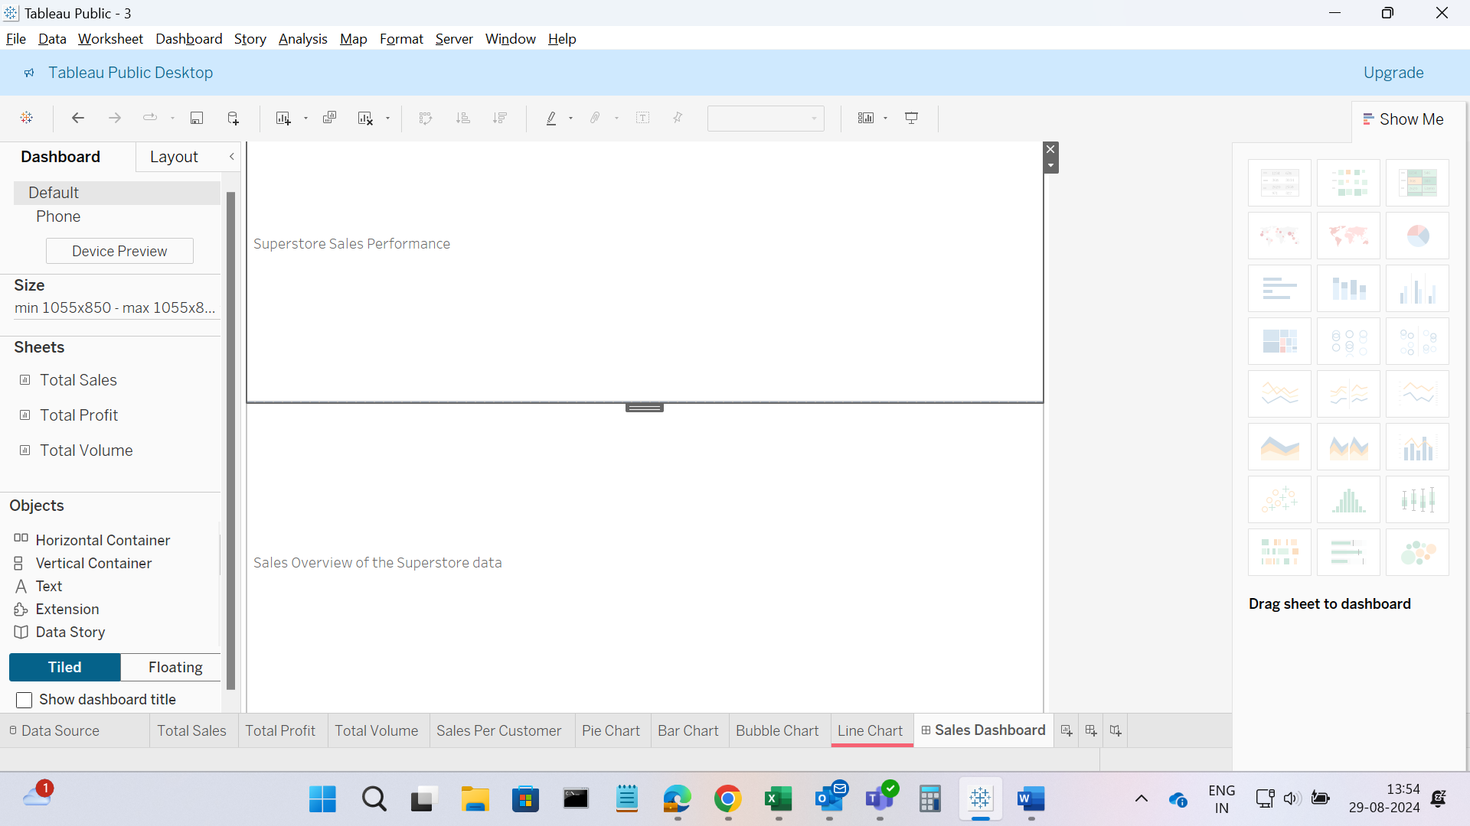

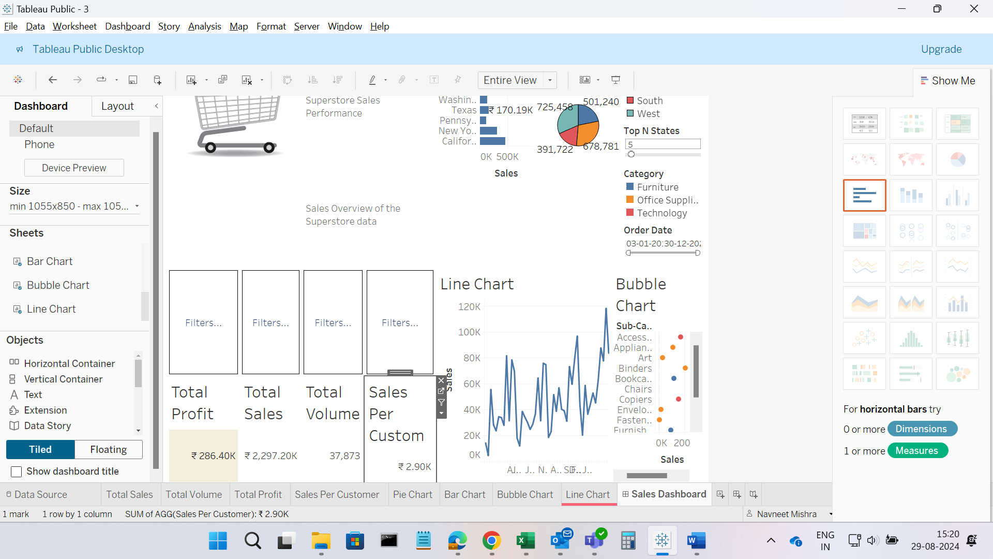

The Final view

